1. List the names of all customers that have a credit limit of $7,500 or less. 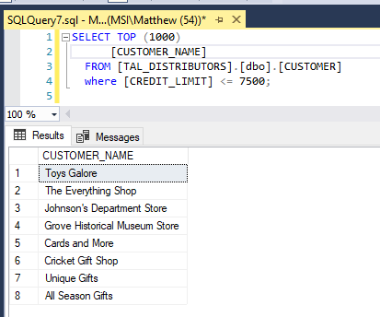
2. List the order numbers for orders placed by customer number 586 on 10/15/2015. 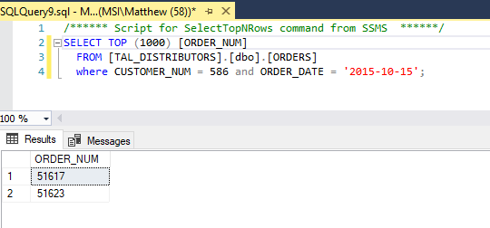
3. List the item number, item description, and on-hand value for each item in category TOY. 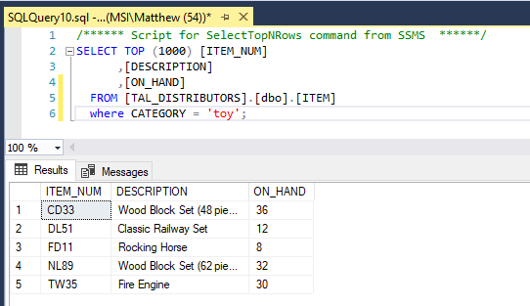
4. List the item number and item description of all items that are in category PZL. 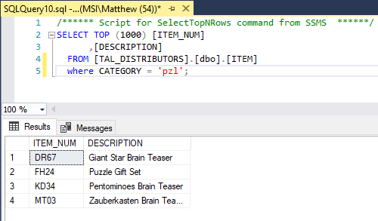
5. How many customers have a balance that exceeds their credit limit? 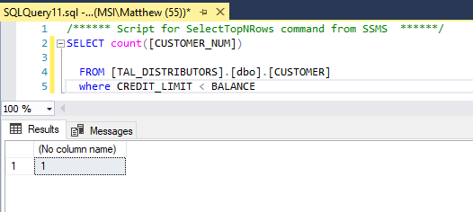
6. What is the item number, description, and price of the least expensive item in the database? 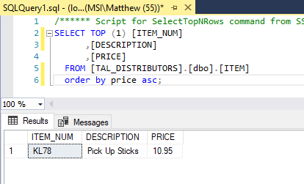
7. For each order, list the order number, order date, customer number, and customer name. 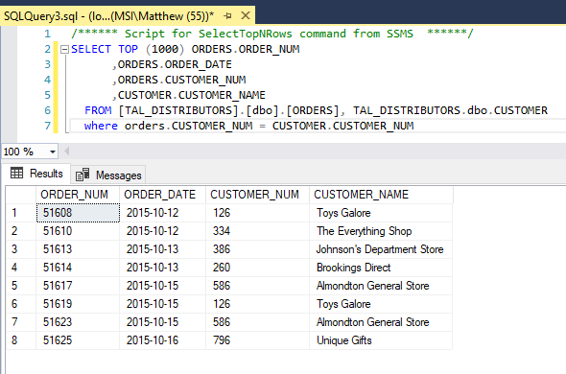
8. For each order placed on October 13, 2015, list the order number, customer number, and customer name. 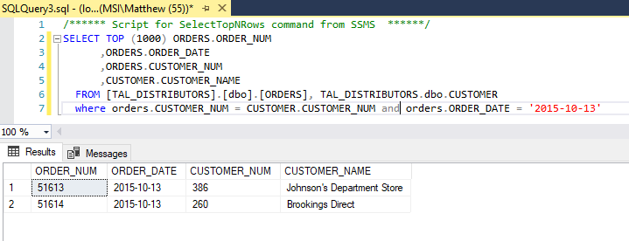
9. List the sales rep number and name for every sales rep who represents at least one customer with a credit limit of $10,000. 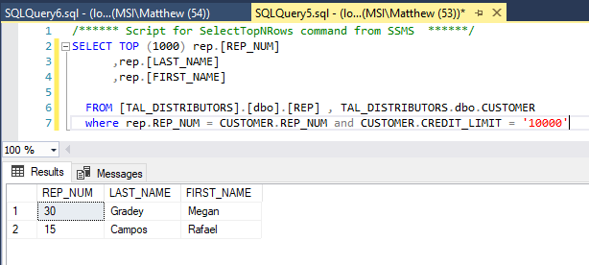
10. For each order placed on October 12, 2015, list the order number, item number, item description, and category for each item ordered. 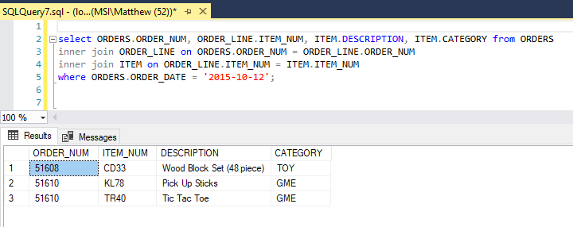
11. TAL Distributors needs to be able to contact customers when problems arise concerning an order. What other types of data could TAL include in the CUSTOMER table to assist in contacting customers?

Customers’ personal contact information such as email address, physical address, phone number, ect. These fields are all exclusively unique to the individual customer, and therefore belong directly on the CUSTOMER table.